Components in passenger compartment
Removing and installing top left/right dash-panel vent

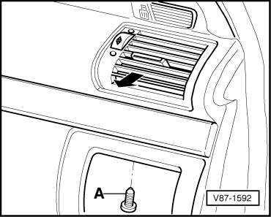
- ‒ Removing bottom left/bottom right dash-panel vent =>Page 80-44.
- ‒ → Screw out bolt -A-.
- ‒ Use auxiliary tools to pull dash-panel vents out of dash panel.
Note:
Making auxiliary tool =>Page 80-42.

