Electrically adjustable sports seats
Removing and installing motors and senders for height/longitudinal adjustment
- ● Front and rear seat height adjustment mechanism moved to highest position.
- ● Seat removed
Notes:
- ◆ Moving seat mechanically forwards and backwards to remove in the event of defective longitudinal adjustment mechanism => Page 72-52.
- ◆ After removing seat raising can be achieved by connecting height adjustment motors directly to a voltage source. Connector to motor must be detached.
- ◆ Voltage must not be applied to control unit for seat adjustment with memory.
- ◆ If seat cannot be raised due to defective height adjustment motor, cut through appropriate drive shaft with cut-off grinder (remove cover seat when doing so) and remove motor. Replace drive shaft that has been cut.
Removing

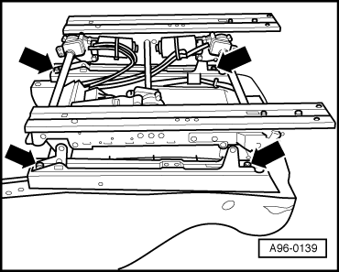
- ‒ → Unscrew the 4 bolts -arrows- for seat bracket.
- ‒ Detach bracket to seat frame.

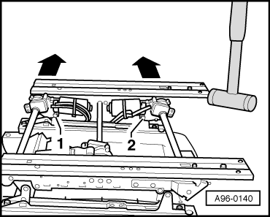
- ‒ → Screw out nuts -1- and -2- at motors for front/rear height adjustment.
- ‒ Cut open cable tie.
- ‒ Detach connectors.
- ‒ Use plastic-headed hammer to drive runner outwards -arrows- on height adjustment motor side.
- ‒ Pull motor for front/rear height adjustment off drive shaft.
- ‒ Press sender for front/rear height adjustment out of clamp at motor.
- ‒ Detach motor for longitudinal adjustment.
- ‒ Detach connectors.
- ‒ Detach drive shaft and pull motor for longitudinal adjustment off drive shaft.
- ‒ Press sender for longitudinal adjustment out of clamp at motor.
Installing
Note:
Ensure that the two runners are parallel.

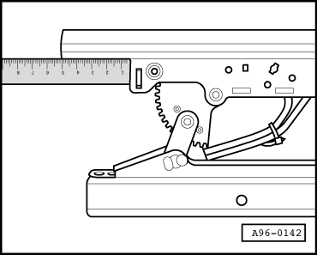
- ‒ Refer to installation position (lug) when fitting new sender.
- ‒ Attach motor with drive shaft for longitudinal adjustment at runner.
- ‒ → Measure fore-and-aft setting of runner on motor side and adjust opposite runner to same dimension.

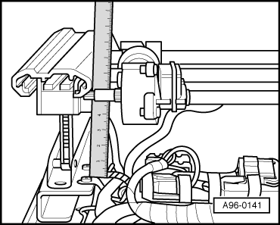
- ‒ Attach motor for front and rear height adjustment to drive shafts.
- ‒ Position both runners on seat frame and insert guide lugs into holes at seat frame.
- ‒ → Measure height adjustment setting at front and rear of one runner and adjust opposite runner to same dimensions.

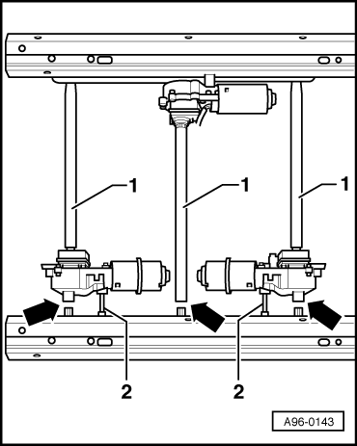
- ‒ → Attach runner to drive shafts -1- in this position and at the same time insert motor securing pins -2-.
- ‒ Measure parallel adjustment again.
- ‒ Screw runner to seat frame to 20 Nm.
- ‒ Screw on motor for longitudinal adjustment to 10 Nm.
- ‒ Screw on (6 Nm) height adjustment motors.
Note:
Synchronisation of sender for longitudinal adjustment/height adjustment senders involves completely traversing entire fore-and-aft, front height and rear height adjustment range.

