Renewing oil retention valves
Note
In the event of irregular valve noise which disappears after a lengthy drive but repeatedly re-occurs when travelling short distances, the oil retention valves must be renewed.

Removing

– | Remove intake manifold → Rep. Gr.24.

 |  | 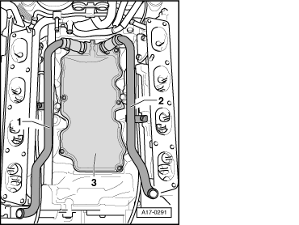
  – | Remove crankcase breather pipes -1- and -2-.
  – | Unbolt cover -3- below intake manifold.

Note |  | 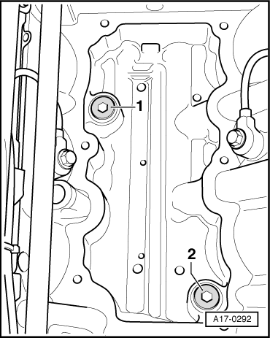
  – | Unscrew oil retention valves -1- and -2-.
  Installing
  Installation is carried out in the reverse order; note the following:
  ⧫ | Renew gaskets, seals and O-rings.
  ⧫ | Secure all hose connections with the correct type of hose clips (same as original equipment) → Parts catalogue.
  – | Install intake manifold → Rep. Gr.24.
  Tightening torque

Component |  | Nm
Oil retention valve to cylinder block |  | 20
Cover to cylinder block |  | 10

