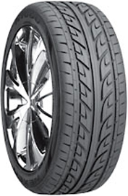

Arrowspeed N1000

Nexen N1000

