Front brake, Brembo brake caliper
Servicing front brakes
Notes:
- ◆ Always install the complete repair kit.
- ◆ After replacing brake pads, depress brake pedal firmly several times with vehicle stationary so that the brake pads are properly seated in the normal operating position.
- ◆ To draw off brake fluid from the reservoir, use a bleeder bottle which is used only for brake fluid. Brake fluid is poisonous and must on no account be siphoned by mouth through a hose.
- ◆ Brakes can be checked on all commercially available brake test stands, provided that the driving speed of the two driving rollers of the test stand does not exceed 5.5 km/h.
- ◆ Always use brake calipers from the same manufacturer with the same quality brake pads for the two wheels on the same axle.
- ◆ The tightening torque of the brake pipes is 15 Nm.

- Brake disc
  - ◆ Always replace all components on an axle
  - ◆ Ensure adequate wear reserve
  - ◆ Remove brake caliper prior to removing
=> Brake System; Repair group 00; Technical data
- Brake caliper
  - ◆ If assembly work is required, do not leave caliper hanging from brake hose but secure it to bodywork with wire
  - ◆ With the exception of "Replacing brake pads"=> Page 47-22, no further repairs may be performed on the brake calipers.
=> Brake System; Repair group 00; Technical data

- Brake pads
  - ◆ Always replace all components on an axle
  - ◆ Different designs on left and right
  - ◆ Removing and installing
=> Page 46-40
  - ◆ With wear indicator
=> Brake System; Repair group 00; Technical data
- Pad retaining spring
- Retaining pins

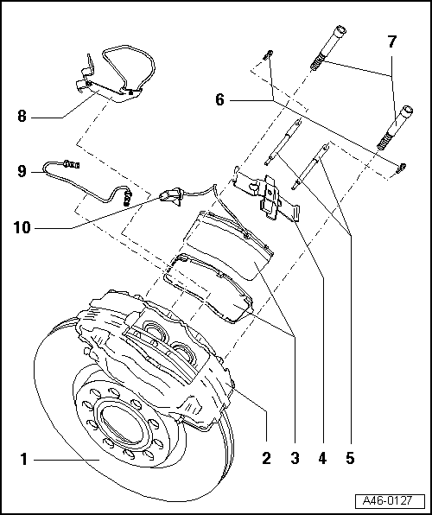
- Locking elements
- Cheese head bolts, 110 Nm
  - ◆ Always replace
- Bracket
  - ◆ Bolt to brake caliper housing
  - ◆ Insert connector for brake pad wear indicator
- Brake pipe, 15 Nm
- Plug connector for brake pad wear indicator
  - ◆ Insert cable for brake pad wear indicator into cable holder
Front brake, Brembo brake caliper
Removing and installing brake pads
Removing
Note:
Mark brake pads to be reused on removal. Reinstall in their original position to prevent uneven braking!
- ‒ Raise vehicle.
- ‒ Remove wheels.

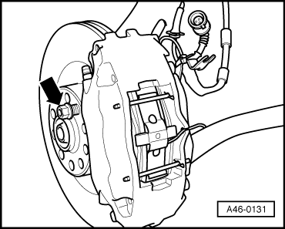
- ‒ → Secure brake disc with a wheel bolt.

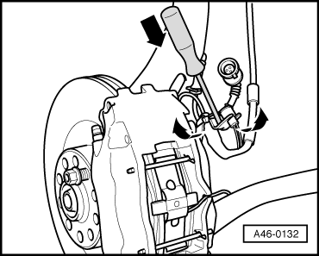
- ‒ Disconnect brake wear indicator connector
- ‒ Release the connector from the holder using a screwdriver, turning connector by 90° at the same time.
- ‒ Pull connector out upwards and unhook the cable.

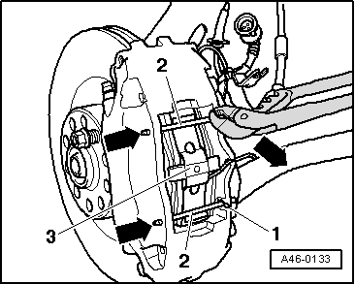
- ‒ Pull out the retainers -1-.
- ‒ Slide out the locking bolts -2- inwards => see arrow
- ‒ Take out the tension spring -3-.
Note:
Before pressing back the piston, extract brake fluid from the brake fluid reservoir with a bleeder bottle. Otherwise brake fluid which was used to top up the brake fluid reservoir, may escape and cause damage.
Important
Brake fluid is poisonous and must on no account be siphoned by mouth through a hose.

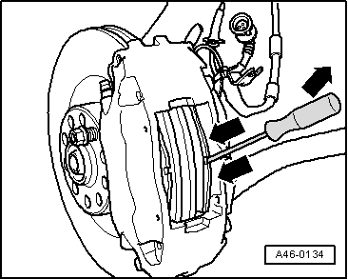
- ‒ → Press piston back into brake caliper housing.
- ‒ To do so, insert piston with screwdriver as shown and press firmly inwards.
- ‒ Carefully take out the inner pad.

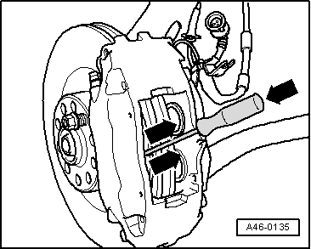
- ‒ → Press piston back into brake caliper housing.
- ‒ To do so, insert piston with screwdriver as shown and press firmly outwards.
- ‒ Carefully take out the outer pad.
Note:
Thoroughly clean brake caliper housing before installing new brake pads.
Installing
Note:
- ◆ Take care not to damage protective caps when inserting brake pads.

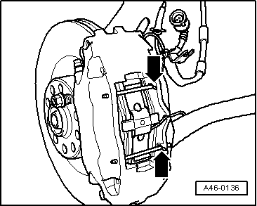
- ‒ → Carefully insert the brake pads.
- ‒ Insert the locking bolt with the tension spring
- ‒ Engage the plug connector for the brake pad wear indicator in the holder and connect it.
Note:
- ◆ Make sure the tension spring is correctly positioned.
- ‒ Insert both retainers => see arrow
- ‒ Unscrew wheel bolt from wheel hub.
Note:
- ◆ When fitting the wheels, ensure that the rim flange does not contact the brake caliper.
- ◆ This could otherwise press the brake pads out of their guides.
- ◆ Each time after replacing the brake pads, depress the brake pedal firmly several times with vehicle stationary so that the brake pads are properly seated in their normal operating position.
- ‒ Fit wheels and tighten to 120 Nm.
- ‒ Check brake fluid level and top up if necessary.

