– | Remove navigation system with CD drive control unit -J401--1- together with mounting frame -2-.

– | Loosen bolt -4-, but do not remove.

– | Unscrew nut -3-.
Note
For better clarity the illustration does not show the complete luggage compartment side trim or other components located near the navigation system with CD drive control unit -J401-.
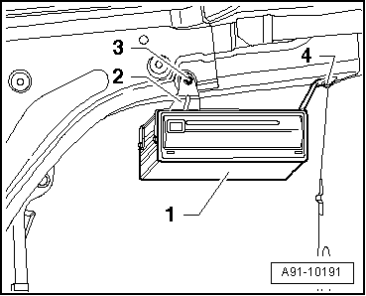

– | Remove navigation system with CD drive control unit -J401--1- together with mounting frame -2- and place aside.
Note
Do NOT unplug connectors on navigation system with CD drive control unit -J401-.
